Solution for Problem 1 (Using ER Assistant Software for creating the diagrams)

* The problem describes three entities – *Customer*, *WorkOrder* and *Task*.
* ***Customer*** requests the work order that contains a set of tasks.
* Minimum Cardinality for the ***Customer-WorkOrder*** relationship is considered as that a single customer can place many number of orders and may have not yet placed an order. (Optional, Many relationship on the ***WorkOrder*** side)
* M-N relationship between ***WorkOrder*** and ***Task*** can be decomposed into two 1-M relationships between associative entity(***WorkStatus***) which records the status, hours, completion-date for a task in a work order.

Initial ER Diagram:

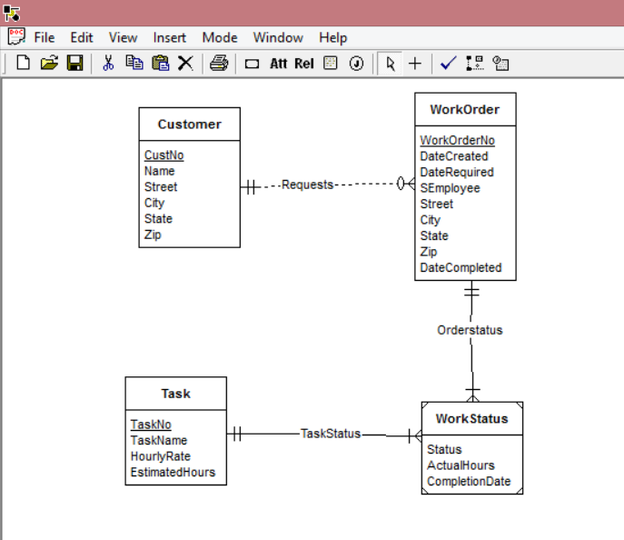

Revisions made on the ER Diagram:

Considering the first requirement ***Materials*** Entity was added with attributes as mentioned.

***WorkOrder*** and ***Materials*** which have M-N relationship, is decomposed into two parts (1-M) relationship.

*EstimatedHours* is deleted from Task Entity and was added in the Weak Entity ***WorkStatus***

Revised ER Diagram:

